ryerson University

Data

CIND110

Organization for Data

Analysts

***Assignment II***

**Practicing SQL Queries**

consider the following entity-relationship in this assignment.

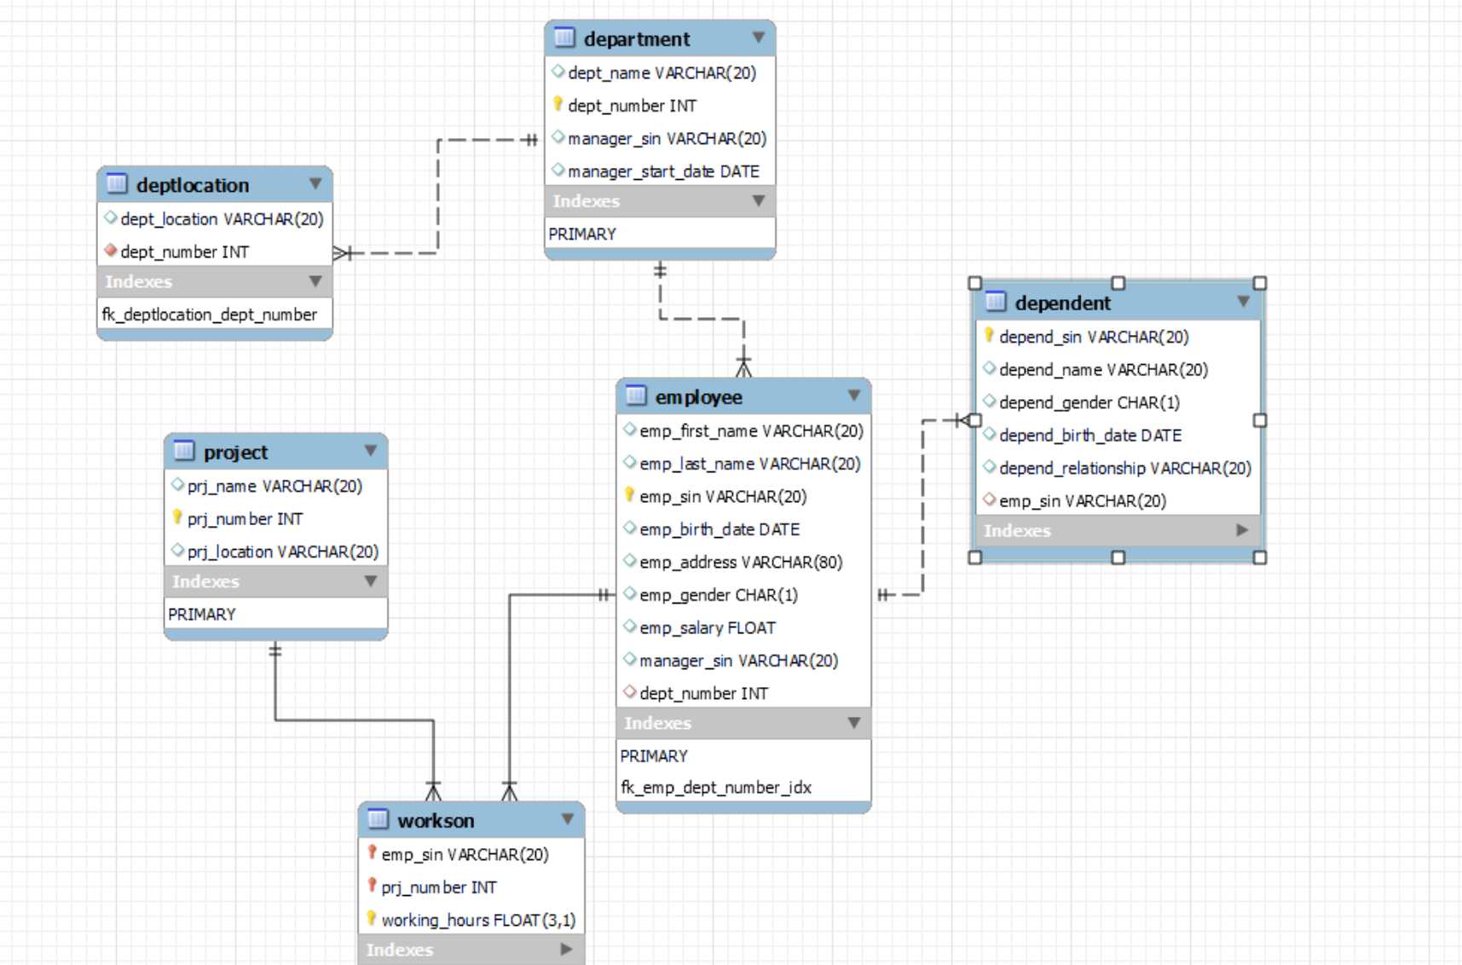

Note: In some questions, I’ve tried to apply more than one query with the same output. Also, in some cases, I added some reports for more investigation.

1. **[5 Pts.]** For every project located in ’Montr´eal’, list the project name, the controlling department number, and the department manager’s last name.

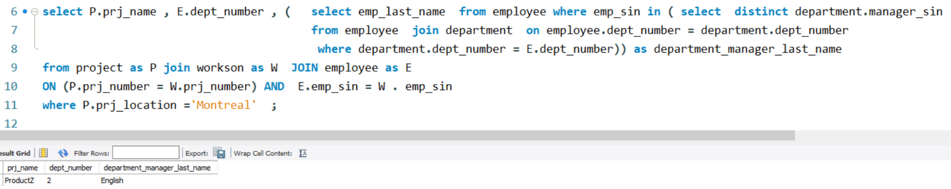

1. **[5 Pts.]** Retrieve repeated addresses and the names of employees who lives at these addresses.

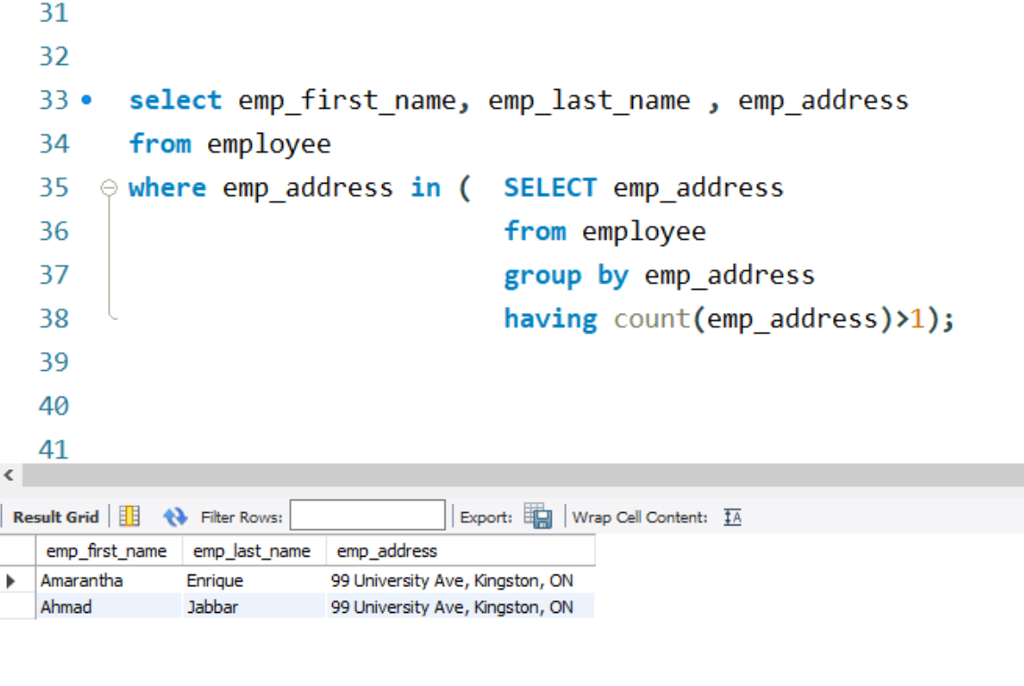

3. **5 Pts.]** Retrieve the first name, address and salary of each employee whose last name starts with the letter ’E’ and works for either the ’Marketing’ or the ’Administration’ department.

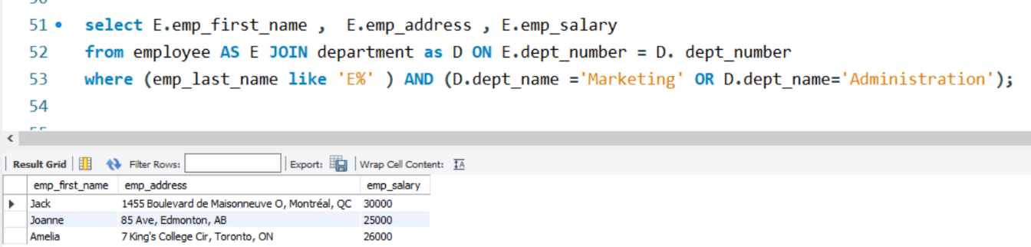

4 . **5 Pts.]** List the names of managers who have at least one dependent.

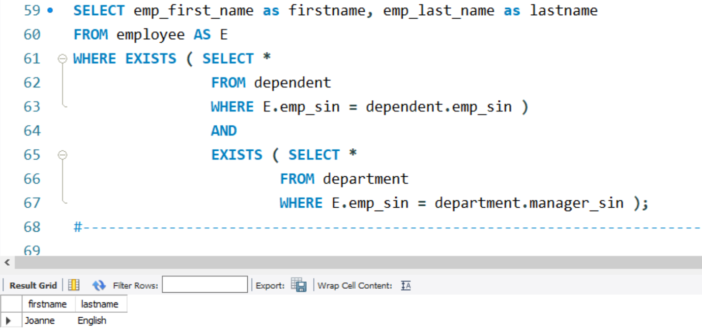

5. [10 Pts.] Find the sum of the salaries of all employees of the ’Marketing’ department.

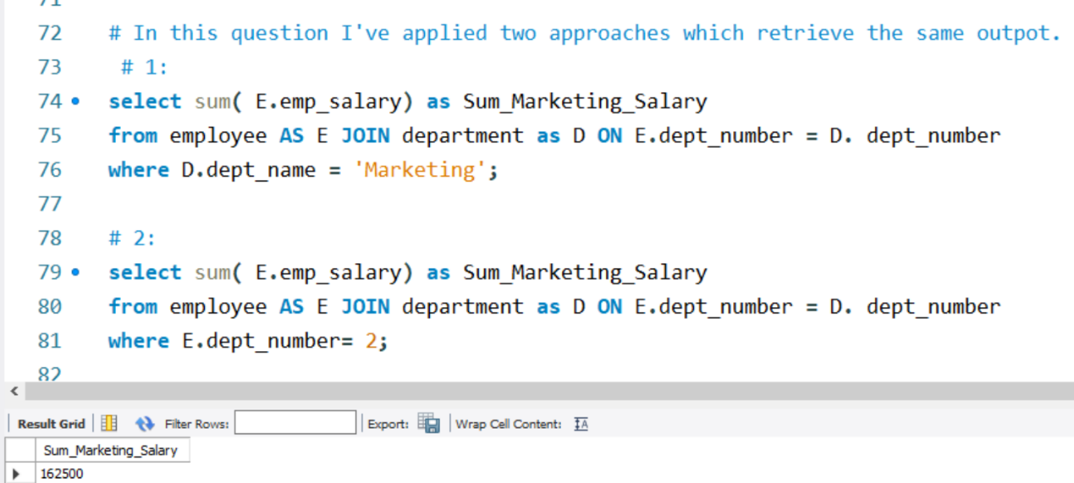

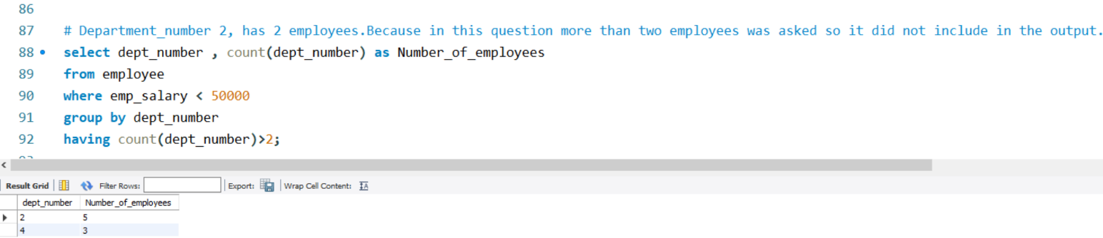**6. 10 Pts.]** For each department that has more than two employees, retrieve the department number and the number of its employees who are making less than $50,000 .

7. **[10 Pts.]** For each department whose average employee salary is less than $90,000, retrieve the department name and the number of employees working for that depart- ment.

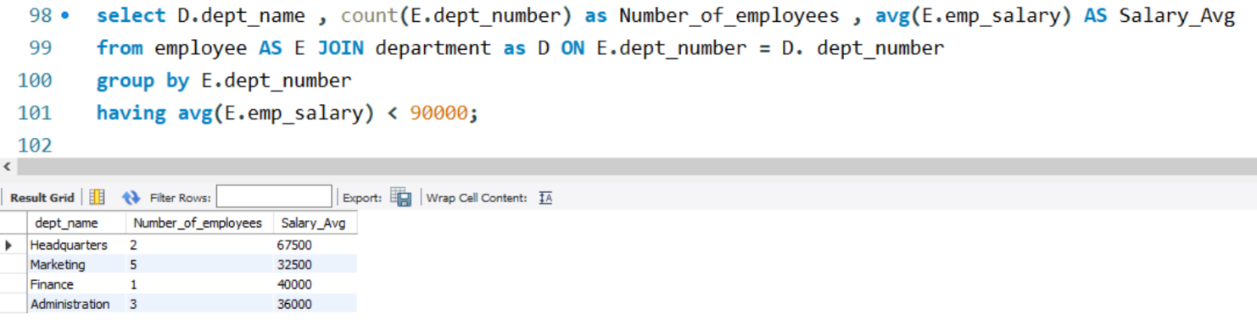

8. **[10 Pts.]** Retrieve the names of all employees who work in the department that has the employee with the highest salary among all employees.

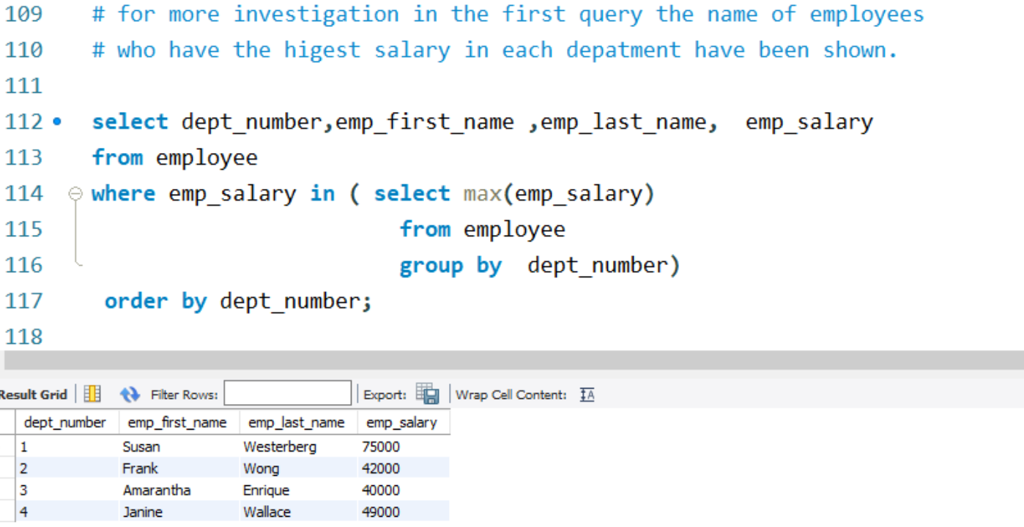

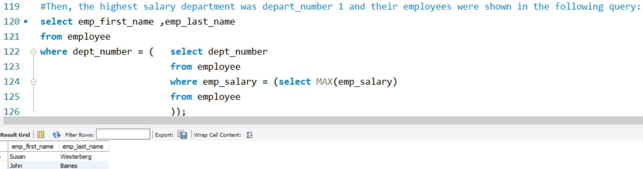

9. [10 Pts.] Retrieve the names of employees who make at least $20,000 more than the employee who is paid the least in the company.

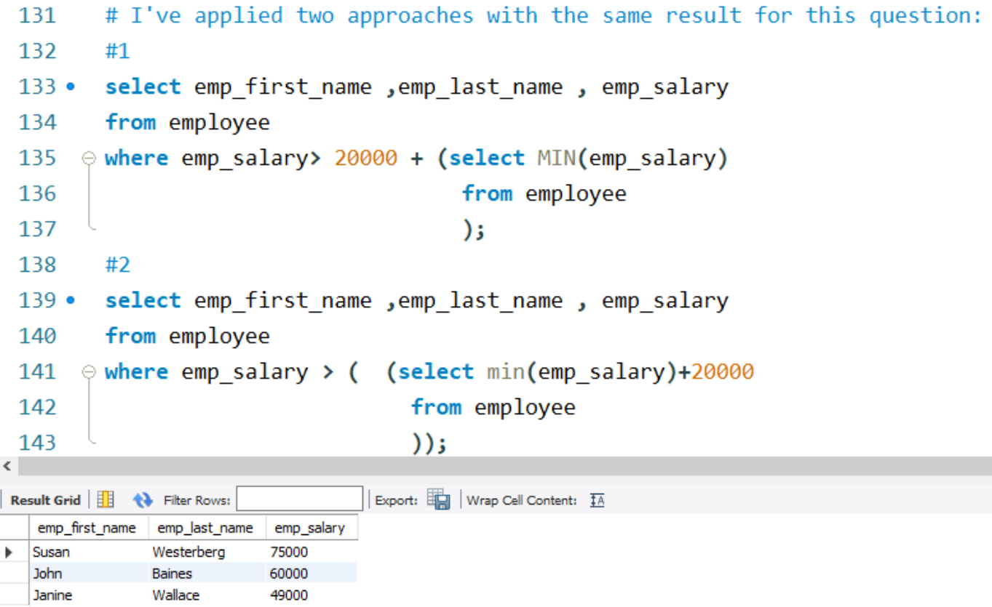

10. [10 Pts.] Find the number of employees who are working on more than 2 projects  
and show the result in descending order.

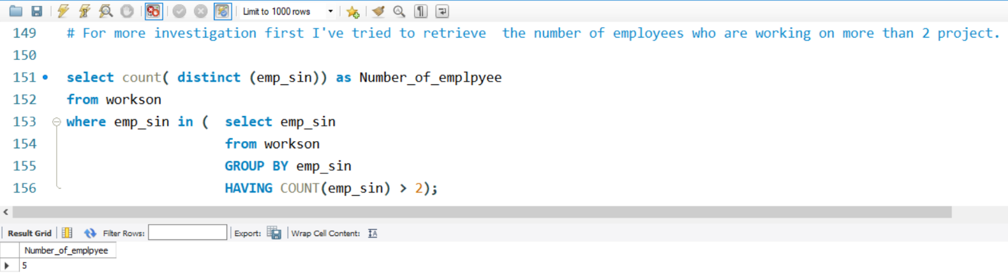

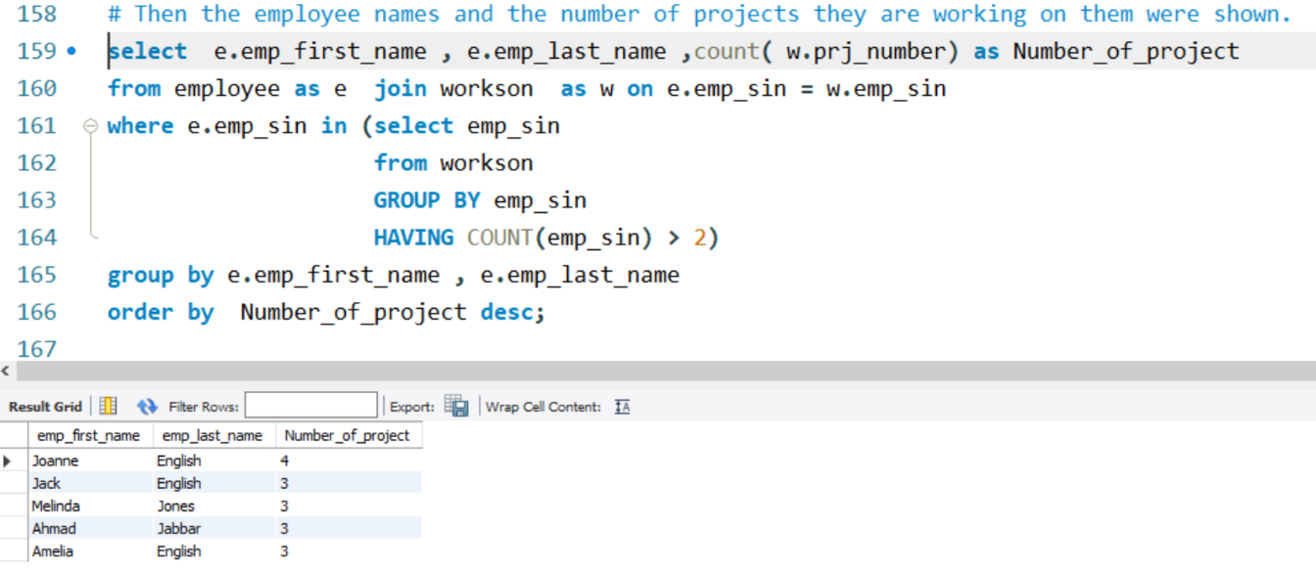

11. [10 Pts.] Retrieve the employee names and their dependent names. Return employee names even if the dependent name is not present for the employee.

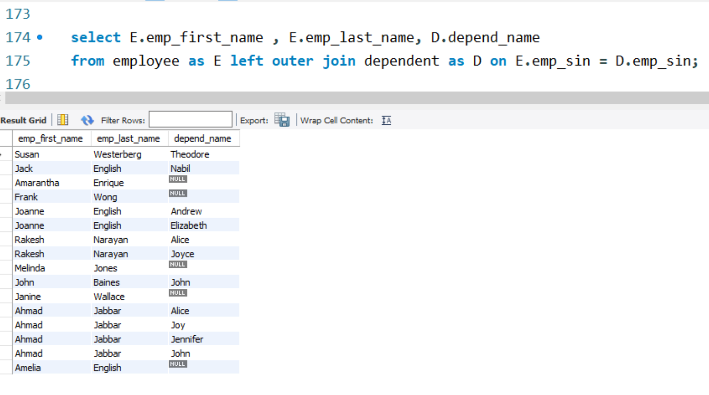

12. **[10 Pts.]** If more than one employee is working on the same project with the same number of hours, then display the number of these employees along with the project number.

